**Nmon Installation and Usage**

* nmon is a computer performance system monitor tool for the AIX and Linux operating systems.
* nmon is short for **N**igel's performance **Mon**itor **for Linux** on POWER, x86, x86_64, Mainframe & now ARM (Raspberry Pi)

**Installation and running:**

1. Install nmon using apt on linux (Ubuntu)

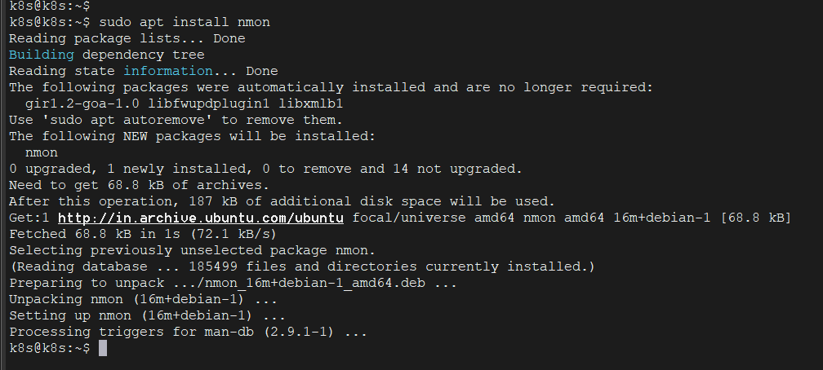

1. Run nmon data collection using the following command

**“ nmon -F Nov12_18ToNov13_10.nmon -s 10 -c 5670 ”**

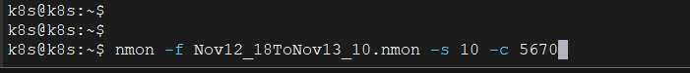

It will create a file with the title “ Nov12_18ToNov13_10.nmon”

1. To create a nmon chart to view the stats as a graph, install nmonchart and run it on the .nmon file. Pull the latest nmonchart tar file from the official website

Extract the tar file.

Change the shell from ksh to bash and save it.

Execute this command to generate .html file.

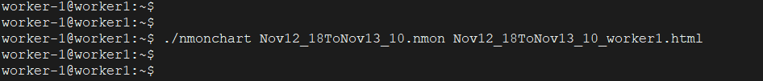

This is the file that got created.

It opens like this on the browser. Here, you can view all the performance statistics.

